MP3: Patter Recognition

Abhi Kamboj

Hockenmaier

3/31/2019

# Section I:

## Part 1.1: Naïve Bayes Model

### Results

#### Overview Screenshot:

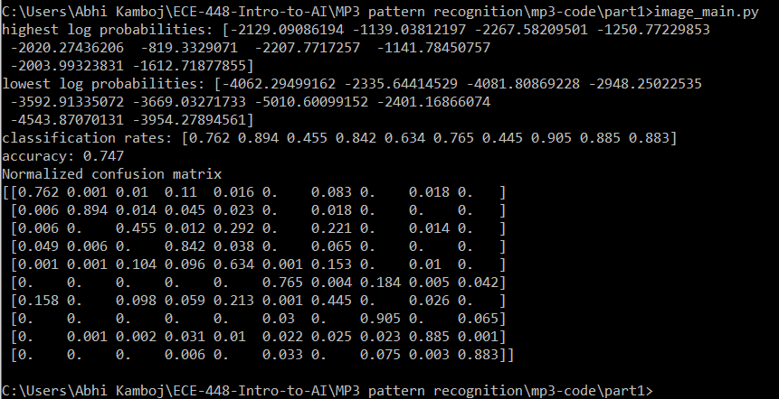

#### Average Classification Rate:

Average Classification Rate: 0.747

#### Classification Rate for Each Class:

classification rates: [0.762 0.894 0.455 0.842 0.634 0.765 0.445 0.905 0.885 0.883]

Indices in the array shown above correspond to classes

#### Confusion Matrix:

#### Highest Posterior Probabilities:

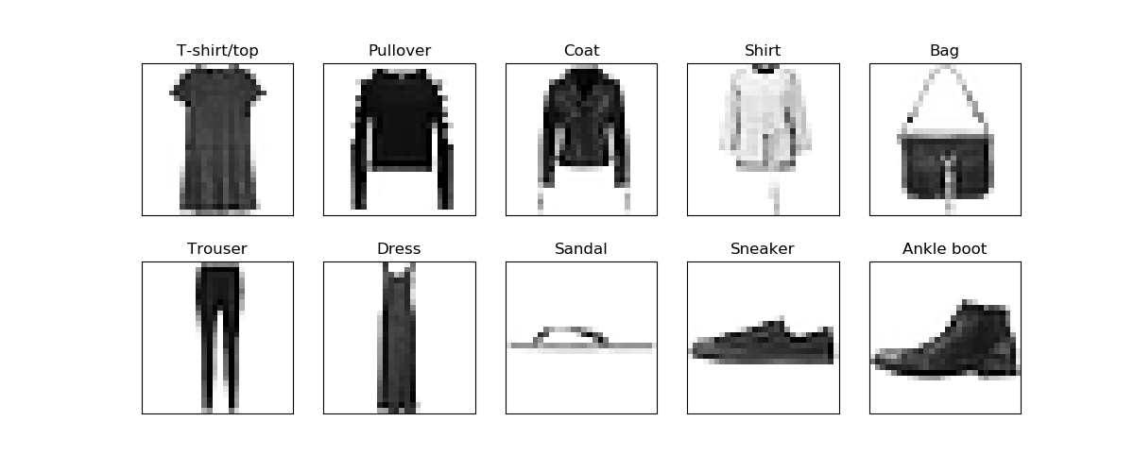

highest log probabilities: [-2129.09086194 -1139.03812197 -2267.58209501 -1250.77229853 -2020.27436206 -819.3329071 -2207.7717257 -1141.78450757 -2003.99323831 -1612.71877855]

#### Lowest Posterior Probabilities:

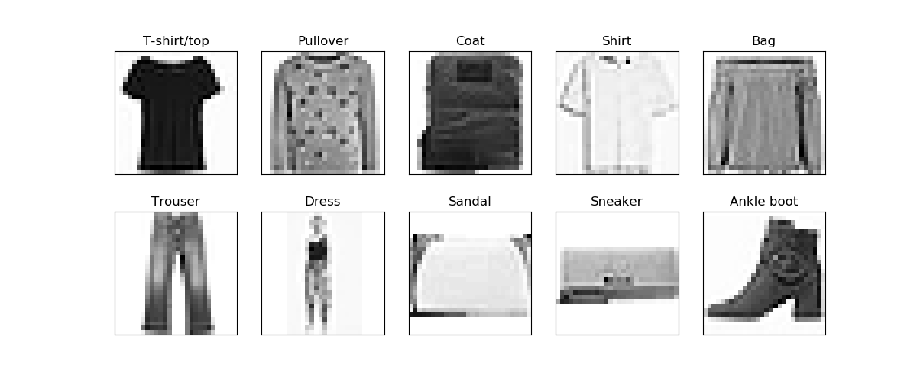

lowest log probabilities: [-4062.29499162 -2335.64414529 -4081.80869228 -2948.25022535 -3592.91335072 -3669.03271733 -5010.60099152 -2401.16866074 -4543.87070131 -3954.27894561]

#### Visualization Plots for Feature Likelihood:

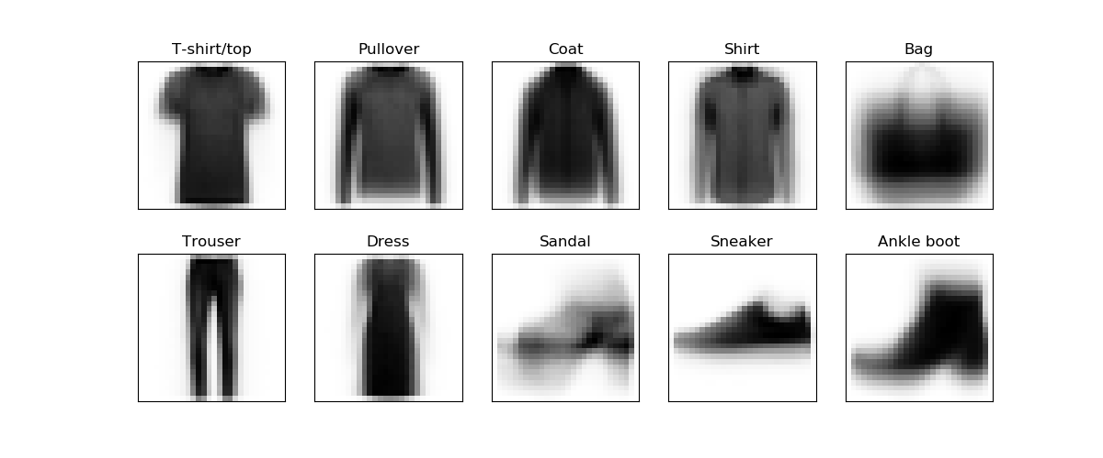

### Optimizations

A program was written testing K values from .1 through 10 to determine which one produced the highest accuracy and it was determined that a K value of .1 gives the highest accuracy.

## Part 1.2: Perceptron Model

### Results

#### Overview Screenshot:

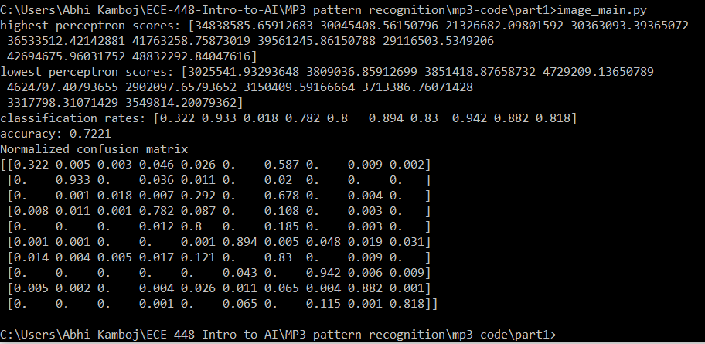

#### Average Classification Rate:

Average Classification Rate: 0.7221

#### Classification Rate for Each Class:

classification rates: [0.322 0.933 0.018 0.782 0.8 0.894 0.83 0.942 0.882 0.818]

Indices in the array shown above correspond to classes

#### Confusion Matrix:

#### Highest Perceptron Scores:

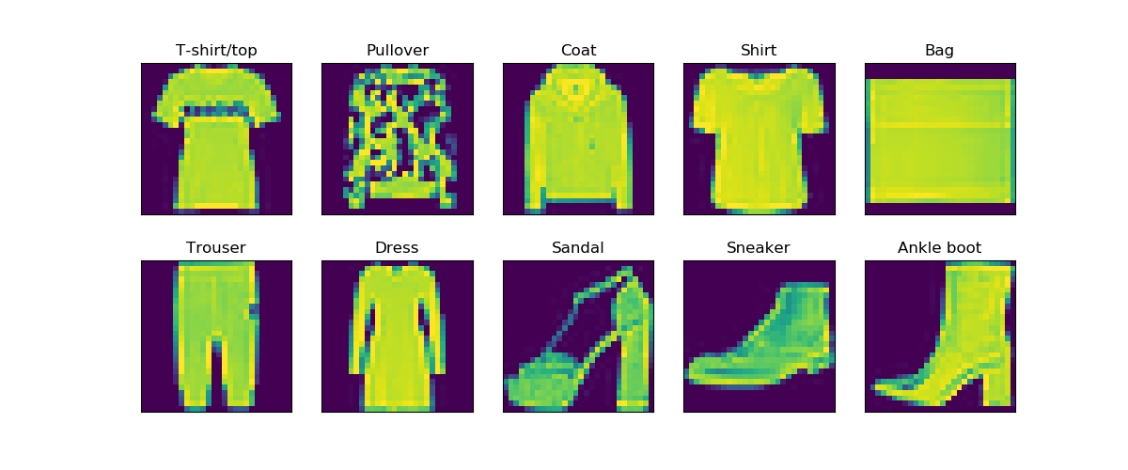

highest perceptron scores: [34838585.65912683 30045408.56150796 21326682.09801592 30363093.39365072 36533512.42142881 41763258.75873019 39561245.86150788 29116503.5349206 42694675.96031752 48832292.84047616]

#### Lowest Perceptron Scores:

lowest perceptron scores: [3025541.93293648 3809036.85912699 3851418.87658732 4729209.13650789 4624707.40793655 2902097.65793652 3150409.59166664 3713386.76071428 3317798.31071429 3549814.20079362]

#### Visualization Plots for Perceptron Weights:

After running through data once:

Average classification rate is .6881

Perceptron weights:

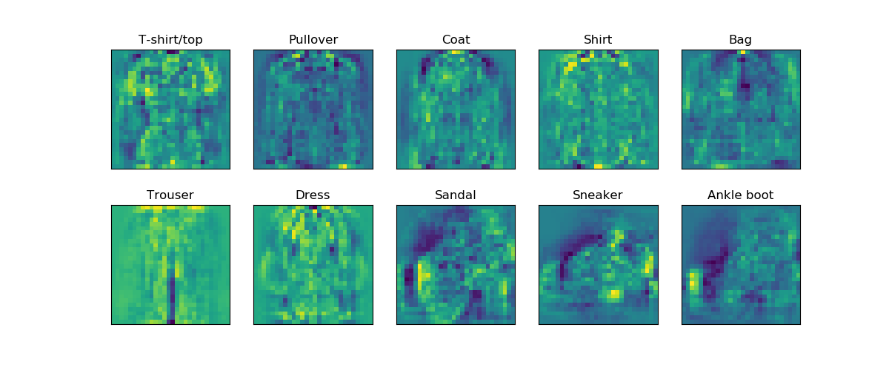

After running through training data 10 times:

Average classification rate is .7221

Perceptron weights:  
 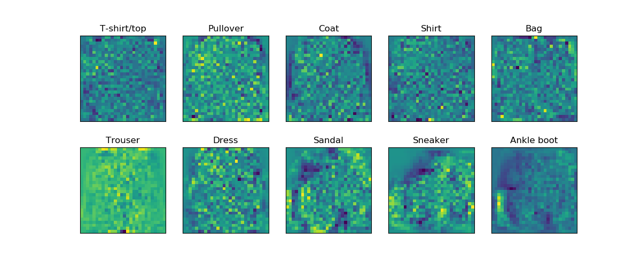

### Optimizations

Initially the perceptron weights were trained by running through the training dataset once and updating the weights accordingly. The perceptron visualizations looked accurate, however the average classification rate was below 70%. The perceptron weights were then trained by running through the data set 10 times each time with a decreasing learning 1/n applied to the weight updates, where n is the trail run the set is on. This increased the accuracy to about 72% however made the perceptron weights a little less visually clear (see Visualization Plots above). This could be because the perceptron weights captured higher dimensional specific features that aren’t as visual for us to see.

# Section II:

## Unigram Model:

### Results:

#### Confusion matrix:

#### Accuracy:

#### Classification Rate, Recall, Precession, F1:

Classification Rate:

Recall:

Precession:

F1:

#### Class Prior Manipulation:

# Extra Credit:

## Bigram and Mixture Model:

### Results

The bigram model decreased the accuracy of the results.

1. Running naive Bayes on the bigram model relaxes the naive assumption of the model a bit. However, is this always a good thing? Why or why not?

Although it does relax the naïve assumption of the model, occasionally that can be a bad thing like in this case since there were not enough training examples. For the bigram model to be successful, it would probably need a robust data set with more possible combinations of 2-word pairs.

1. What would happen if we did an N-gram model where N was a really large number?

The model would fail for very large N, because then you would be looking at almost the entire text sample. In this case, you would be overfitting the data to the text sample, not picking up unique features for the example to work.